 | 

Alternative Assessment Tool (AAT) Report on

“Design and Verification of Combinational and Sequential Digital Modules using Verilog HDL”
Submitted in partial fulfilment of the requirements of the Alternative Assessment Tool (AAT) for the course

ADVANCED DIGITAL AND LOGIC DESIGN (ADLD)
[Course Code: 23ECSPE1AD]

Submitted by

Vismitha JS | 1BF24EC189

Submitted to

Prof. Ajaykumar Devarapalli

DEPARTMENT OF ELECTRONICS AND COMMUNICATION ENGINEERING
BMS College of Engineering
Bull Temple Road, Basavanagudi, Bengaluru-560019

Academic Year
2026 – 2027
INDEX
S.NO | CONTENTS | PAGE NO
1 | Arithmetic Logic Unit (ALU) | 3-5
2 | Shift register | 6-8
3 | Conclusion | 9
4 | Acknowledgement | 10

Arithmetic Logic Unit (ALU)
GitHub Link: https://github.com/vismithajsec24-189/ADLD-AAT-2
The Arithmetic Logic Unit (ALU) is a fundamental digital circuit that performs arithmetic and logical operations on binary data. It is an important component of a processor and other digital systems, as it enables mathematical calculations and logical decision-making. The ALU accepts binary input operands, performs the operation selected by the control signals, and produces the corresponding output.
WORKING PRINCIPLE
The ALU takes two input operands, A and B, along with select signals that determine the operation to be performed. Based on the selected control code, the circuit executes the corresponding arithmetic or logical function. The resulting value is available at the output. Depending on the design, the ALU may also generate status flags such as carry, zero, overflow, and sign flags.
The ALU can be implemented using combinational logic circuits, allowing the output to respond to changes in the input operands or selection signals after the circuit's propagation delay.
CODE: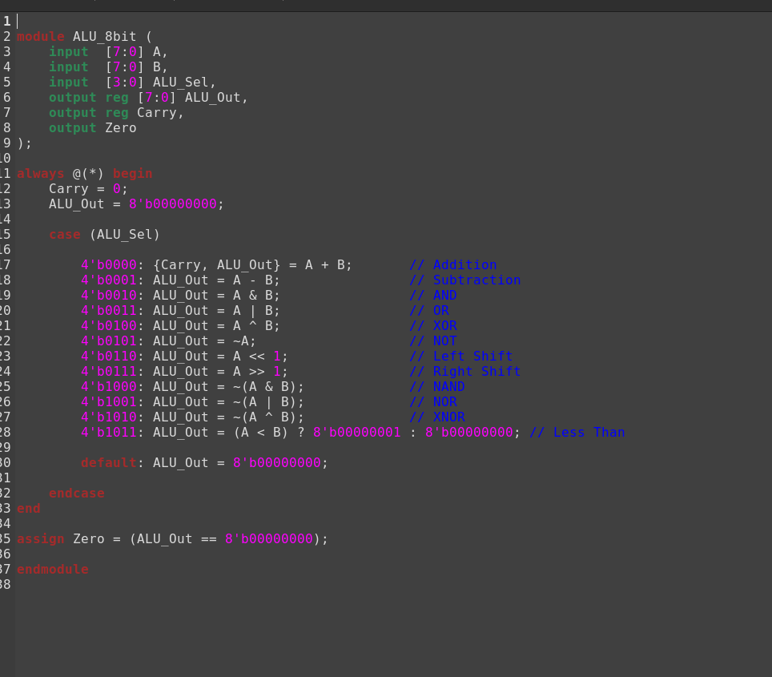

TESTBENCH:
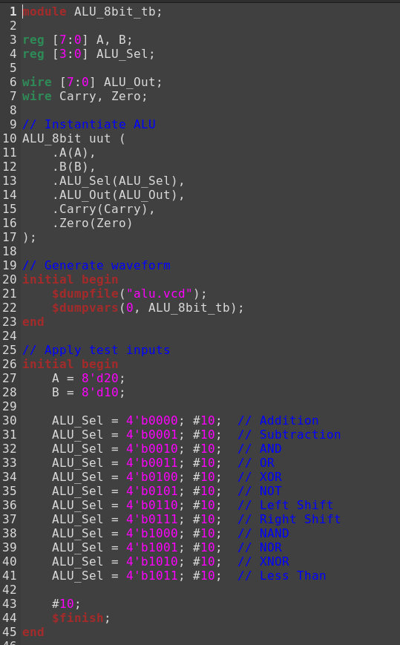
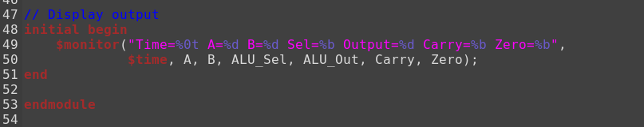
OUTPUT WAVEFORM:
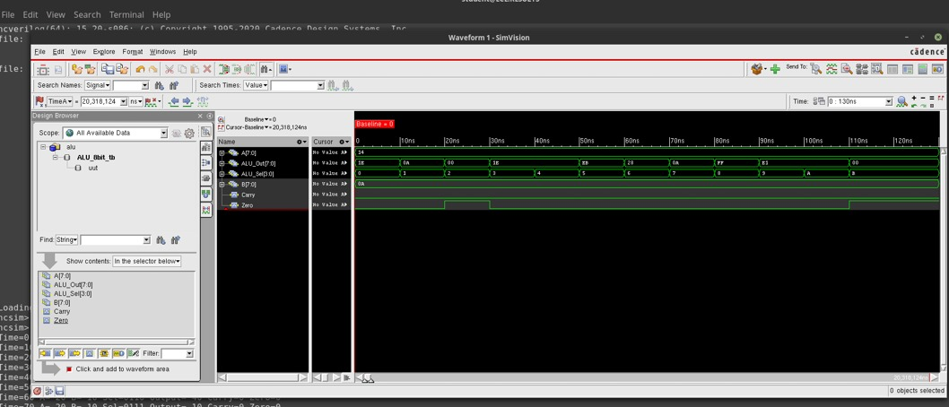

Universal Shift Register
A universal shift register is a sequential digital circuit used to store binary data and perform different shifting operations. It is called a universal shift register because it supports multiple modes of operation, including holding the current data, shifting data to the right, shifting data to the left, and parallel loading of data. The design consists of four bits and is implemented using Verilog HDL. It uses a clock signal, an asynchronous reset, two mode selection inputs, parallel data inputs, and serial inputs for left and right shifting. The four-bit output represents the data currently stored in the register.
Working Principle
The universal shift register operates based on the positive edge of the clock signal. Whenever a rising edge of the clock occurs, the circuit checks the reset signal and the two-bit selection input to determine the operation to be performed. If the reset signal is active, all four output bits are cleared to zero immediately, without waiting for a clock edge. Otherwise, the circuit performs the operation specified by the selection inputs.
The two-bit selection input, sel, determines the mode of operation. When sel = 00, the register holds its previous value without making any changes. When sel = 01, the register performs a right-shift operation, in which the existing bits move one position to the right and the new most significant bit is supplied by serial_in_right. When sel = 10, the register performs a left-shift operation, in which the existing bits move one position to the left and the new least significant bit is supplied by serial_in_left. When sel = 11, the register performs parallel loading, in which all four bits from data_in are loaded into the register simultaneously
CODE: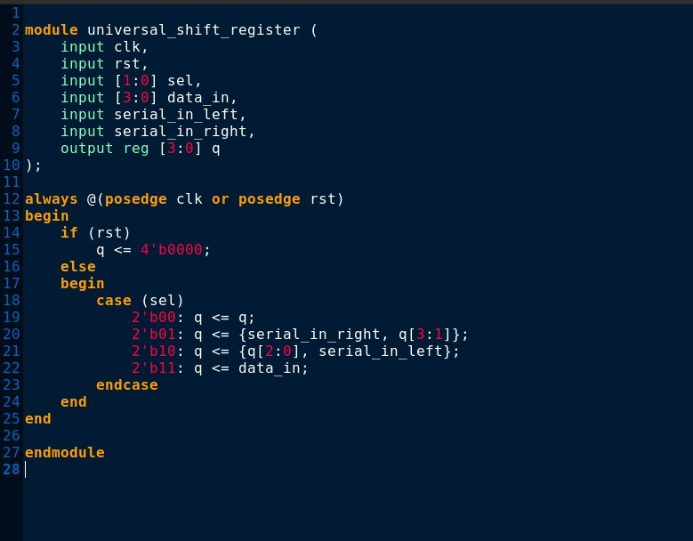
TESTBENCH: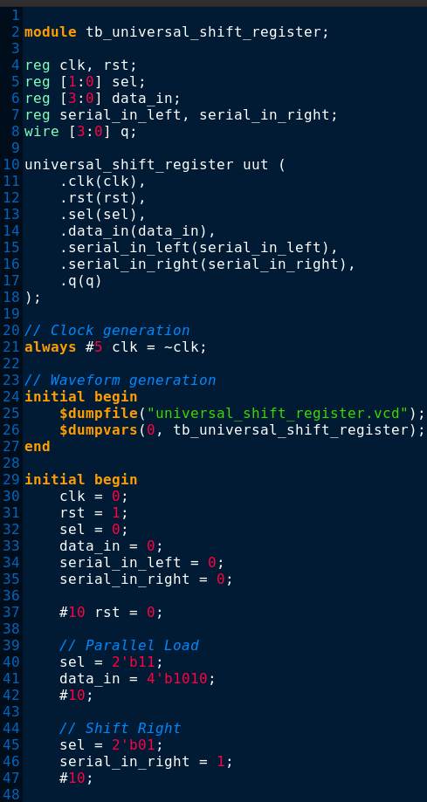
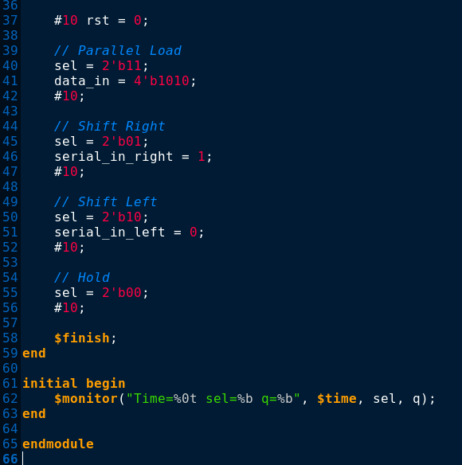

OUTPUT WAVEFORM:
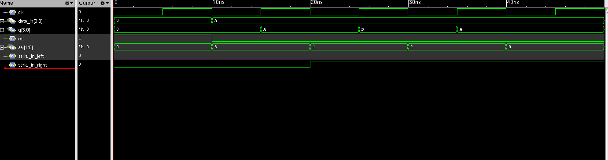

CONCLUSION
The Arithmetic Logic Unit (ALU) and Shift Register were designed and simulated using Cadence tools to understand the fundamental concepts of digital circuit design. The ALU demonstrates the execution of arithmetic and logical operations on binary data based on the selected control signals, while the shift register illustrates the storage and shifting of binary data between flip-flops in response to clock pulses. The simulation results help verify the functionality of both circuits and provide practical knowledge of combinational and sequential logic design. Thus, these circuits form essential building blocks of digital systems and are widely used in processors, microcontrollers, and data processing applications.

ACKNOWLEDGEMENT
I would like to express my sincere gratitude to Prof. Ajaykumar Devarapalli for his valuable guidance and support throughout the completion of this Alternative Assessment Tool (AAT) report for the course Advanced Digital and Logic Design (ADLD). His guidance helped me understand the design and simulation of digital circuits using Verilog HDL and Cadence tools.
I am also thankful to the Department of Electronics and Communication Engineering, BMS College of Engineering, for providing me with the opportunity and academic environment to carry out this work on the design and verification of the Arithmetic Logic Unit (ALU) and Shift Register using Verilog HDL and Cadence simulation tools.
Finally, I would like to thank everyone who contributed directly or indirectly to the successful completion of this report.

Vismitha JS
USN: 1BF24EC189

